VRF

Reed Holman | CCNP | 2/1/2023

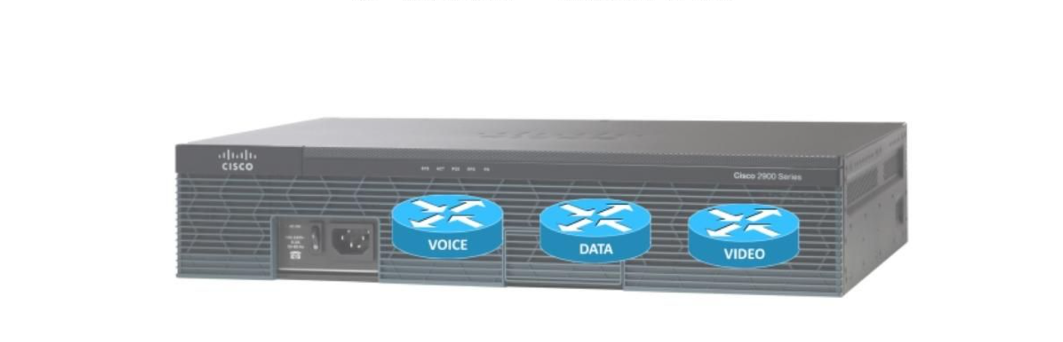

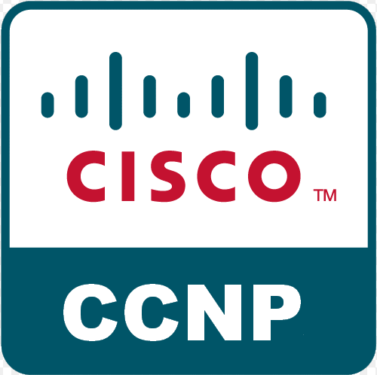

Purpose:

The point of this lab was to create two different networks that shared the same routers. The two different networks should not be able to talk to each other.

Background Information:

Virtualization gives us the ability to house multiple networks in a single physical device. It is mainly used when different organizations, departments or companies that potentially are using different physical routers but are using the same Layer 1 or Layer 2 devices. It does allow for one router to have multiple different routing tables to hold the information for each network. VRF is useful because it does not require static routes to have different networks. When using VRF the different networks are able to overlap or even have the exact same IP scheme and it doesn’t cause any problems.

VRF was first in tandem with Multiprotocol Label Switching (MPLS), but people soon found VRF so useful that they started to use solo. Multiprotocol Label Switching is a way of routing that doesn’t rely on network addresses to route packets, instead it uses labels. IP addresses use endpoints to know where a packet is going while labels use defined paths between endpoints. This allows it to encapsulate different types of packets using different network protocols. VRF combined with Multiprotocol Label Switching is an easily integrated and very scalable feature that can easily be added to a network. VRF also provides multiple routing instances in a single Cisco IOS.

Lab Commands:

-Vrf definition [name]

-Ip vrf forwarding [name]

-Router osfp [number] vrf [name]

Network Diagram:

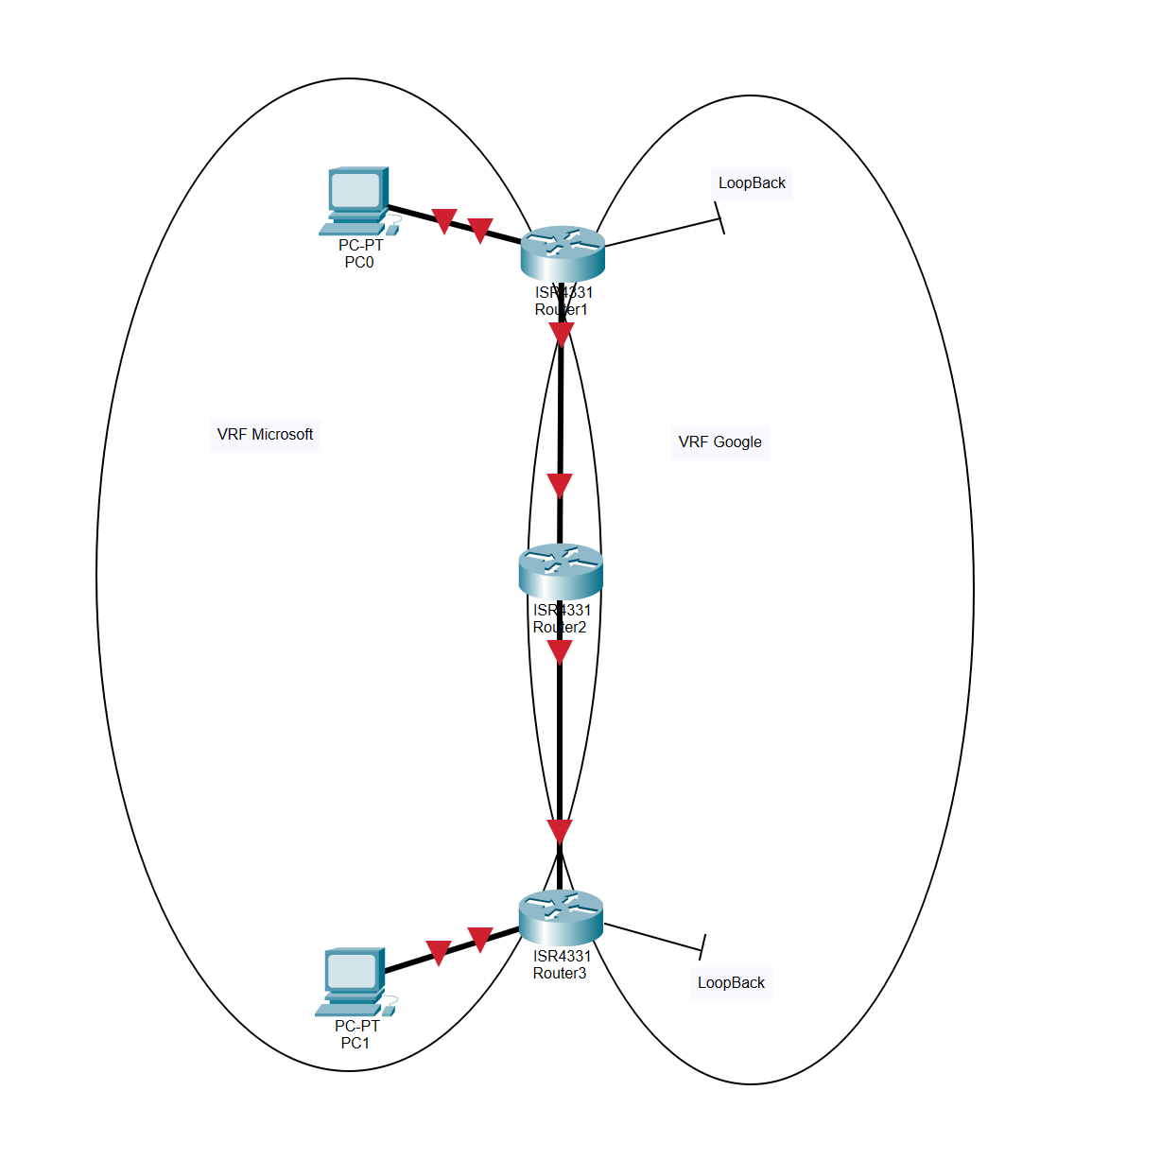

Configurations:

R1:

hostname R1

boot-start-marker

boot-end-marker

vrf definition Google

rd 65000:10

address-family ipv4

exit-address-family

vrf definition Mgmt-intf

address-family ipv4

exit-address-family

address-family ipv6

exit-address-family

vrf definition Microsoft

address-family ipv4

exit-address-family

no aaa new-model

login on-success log

subscriber templating

vtp domain cisco

vtp mode transparent

multilink bundle-name authenticated

license udi pid ISR4321/K9 sn FDO21482HZX

no license smart enable

diagnostic bootup level minimal

spanning-tree extend system-id

redundancy

mode none

interface Loopback0

vrf forwarding Google

ip address 192.168.1.1 255.255.255.0

interface GigabitEthernet0/0/0

no ip address

negotiation auto

interface GigabitEthernet0/0/0.1

encapsulation dot1Q 10

vrf forwarding Microsoft

ip address 192.168.10.1 255.255.255.0

interface GigabitEthernet0/0/0.2

encapsulation dot1Q 20

vrf forwarding Google

ip address 192.168.10.1 255.255.255.0

interface GigabitEthernet0/0/1

vrf forwarding Microsoft

ip address 192.168.1.1 255.255.255.0

negotiation auto

interface Serial0/1/0

no ip address

shutdown

interface Serial0/1/1

no ip address

shutdown

interface GigabitEthernet0

vrf forwarding Mgmt-intf

no ip address

shutdown

negotiation auto

router ospf 1 vrf Microsoft

network 192.168.1.0 0.0.0.255 area 0

network 192.168.10.0 0.0.0.255 area 0

router ospf 10 vrf Google

network 192.168.1.0 0.0.0.255 area 0

network 192.168.10.0 0.0.0.255 area 0

ip forward-protocol nd

no ip http server

no ip http secure-server

ip tftp source-interface GigabitEthernet0

control-plane

line con 0

transport input none

stopbits 1

line aux 0

stopbits 1

line vty 0 4

login

end

R2:

hostname R2

boot-start-marker

boot-end-marker

vrf definition Google

address-family ipv4

exit-address-family

vrf definition Mgmt-intf

address-family ipv4

exit-address-family

address-family ipv6

exit-address-family

vrf definition Microsoft

address-family ipv4

exit-address-family

no aaa new-model

login on-success log

subscriber templating

vtp domain cisco

vtp mode transparent

multilink bundle-name authenticated

crypto pki trustpoint TP-self-signed-2105456491

enrollment selfsigned

subject-name cn=IOS-Self-Signed-Certificate-2105456491

revocation-check none

rsakeypair TP-self-signed-2105456491

crypto pki certificate chain TP-self-signed-2105456491

certificate self-signed 01

30820330 30820218 A0030201 02020101 300D0609 2A864886 F70D0101 05050030

31312F30 2D060355 04031326 494F532D 53656C66 2D536967 6E65642D 43657274

69666963 6174652D 32313035 34353634 3931301E 170D3233 30323031 31373231

34395A17 0D333030 31303130 30303030 305A3031 312F302D 06035504 03132649

4F532D53 656C662D 5369676E 65642D43 65727469 66696361 74652D32 31303534

35363439 31308201 22300D06 092A8648 86F70D01 01010500 0382010F 00308201

0A028201 0100CE2B 79477590 6B47F8AC 8DAB27BD 5EB72B93 C6167A42 5289BC3E

FF2A484B 87C1A2F2 730B3006 C0A35F42 192A87F7 44AF0D9D 0C3E5006 03B50805

B54D27F2 8F0ACE05 39CF6CAE 53E2581F 5E963872 B98F7EEC 6DFA0B3C 63CC99E8

2DE6A8AD 8E734163 8126E486 B026B9F1 31DDFB30 B2CB8381 DE5E305D C680DD71

4EA97471 3F597258 13F9FAA7 05501B16 28AEE074 5E2DDD89 2EB3DD09 C144A21C

F43B37BB 00FA9255 0EE3145A 1BB9BD39 6D4C7476 BF7918E1 F4E3074D 258141C0

5694AEC9 B3F047C8 7BD07FED 40E74EC7 44C16721 8E5EF55B 5BE19144 0F70CE95

974AE58B AF953605 0E571D27 1D50612A 023A7E7A 661FDB48 FFA50034 24A880B3

19C0C6E0 1C3B0203 010001A3 53305130 0F060355 1D130101 FF040530 030101FF

301F0603 551D2304 18301680 1433C028 77E5CA75 F3EB3B21 E2CA9623 74112A77

3A301D06 03551D0E 04160414 33C02877 E5CA75F3 EB3B21E2 CA962374 112A773A

300D0609 2A864886 F70D0101 05050003 82010100 B4250381 2D1AB368 4809CAD1

D290A547 A85D2AD6 4B443AD2 E334DC33 045580A3 4CEC3FEC BB01D25F 1CAA0980

955F7A6B F536C47B E9B76DB2 E4A29B72 25C2D422 080A23CE 4C84A025 DB5DF1C0

00FCCD49 950E1FE4 3956F751 BCD8B035 0139FA0E 86C33E58 B722C679 A0195EC2

BFD4F1C1 087CF115 ECF9F726 2660122E 7D80B7BC 175FAEA6 4429C74B CB55C45A

D80FD804 53D31395 B76860AA 36ED7208 03354FB1 A6B1CC62 C0948A41 75F6D952

25508DBB 287681B6 800FA017 32DE8FA9 FA12074B FF4EC9ED 25CB7929 00B06D3D

67235286 9680A5C5 3346CC4B 5E541C10 FE27BCFE 430A5813 0A5BFD27 B1436332

3132AA80 C5F124D4 7E9A24D6 456A0407 B3BC82B7

quit

license udi pid ISR4321/K9 sn FDO21482DWJ

no license smart enable

diagnostic bootup level minimal

spanning-tree extend system-id

redundancy

mode none

interface GigabitEthernet0/0/0

no ip address

negotiation auto

interface GigabitEthernet0/0/0.1

encapsulation dot1Q 10

vrf forwarding Microsoft

ip address 192.168.20.2 255.255.255.0

interface GigabitEthernet0/0/0.2

encapsulation dot1Q 20

vrf forwarding Google

ip address 192.168.20.2 255.255.255.0

interface GigabitEthernet0/0/1

no ip address

negotiation auto

interface GigabitEthernet0/0/1.1

encapsulation dot1Q 10

vrf forwarding Microsoft

ip address 192.168.10.2 255.255.255.0

interface GigabitEthernet0/0/1.2

encapsulation dot1Q 20

vrf forwarding Google

ip address 192.168.10.2 255.255.255.0

interface Serial0/1/0

interface Serial0/1/1

interface GigabitEthernet0

vrf forwarding Mgmt-intf

no ip address

shutdown

negotiation auto

router ospf 1 vrf Microsoft

network 192.168.10.0 0.0.0.255 area 0

network 192.168.20.0 0.0.0.255 area 0

router ospf 10 vrf Google

network 192.168.10.0 0.0.0.255 area 0

network 192.168.20.0 0.0.0.255 area 0

network 192.168.30.0 0.0.0.255 area 0

ip forward-protocol nd

ip http server

ip http authentication local

ip http secure-server

ip tftp source-interface GigabitEthernet0

control-plane

line con 0

transport input none

stopbits 1

line aux 0

stopbits 1

line vty 0 4

login

end

R3:

hostname R3

boot-start-marker

boot-end-marker

vrf definition Google

address-family ipv4

exit-address-family

vrf definition Mgmt-intf

address-family ipv4

exit-address-family

address-family ipv6

exit-address-family

vrf definition Microsoft

address-family ipv4

exit-address-family

no aaa new-model

login on-success log

subscriber templating

vtp domain cisco

vtp mode transparent

multilink bundle-name authenticated

crypto pki trustpoint TP-self-signed-2949602955

enrollment selfsigned

subject-name cn=IOS-Self-Signed-Certificate-2949602955

revocation-check none

rsakeypair TP-self-signed-2949602955

crypto pki certificate chain TP-self-signed-2949602955

certificate self-signed 01

30820330 30820218 A0030201 02020101 300D0609 2A864886 F70D0101 05050030

31312F30 2D060355 04031326 494F532D 53656C66 2D536967 6E65642D 43657274

69666963 6174652D 32393439 36303239 3535301E 170D3233 30323031 31363139

33355A17 0D333030 31303130 30303030 305A3031 312F302D 06035504 03132649

4F532D53 656C662D 5369676E 65642D43 65727469 66696361 74652D32 39343936

30323935 35308201 22300D06 092A8648 86F70D01 01010500 0382010F 00308201

0A028201 010090C8 5C363922 6AB9ABDE 07D2F8E3 D7A6DEAE 80AA6033 3775AD08

66F96943 6E7BD086 7FD425C4 3ECFA697 5BAAD300 724168A5 140FC5DC 5671F080

A307DAE7 A55EF518 14610655 0224EBA5 9AC6DF38 DF483251 3D08B5F8 26E1DECB

7B275485 DFA2214D 725CEFCB 65CA6253 8F5E4D38 3864D893 9F09158D 2D6E1E22

9DA29DC1 8C665B62 46C1F3AC 6883B3C2 DC780665 753A6A65 651AB7A2 783127CC

212BA5D6 D3EF143C D11A8C2D 458F58BA 79015910 C5820884 EDE384A6 089B4FCA

BB2AB7B5 E18BD809 C29E7F3C C8D9D874 7284BCFE AC853C92 38187AA9 5676C516

105EC324 2A7AA2B7 9206199E B2450262 E21D6722 ACFCAB64 2BF34608 E6182338

0A6C5C42 CC310203 010001A3 53305130 0F060355 1D130101 FF040530 030101FF

301F0603 551D2304 18301680 1471018A 6FD5EA3F 64693316 D25D574F D3FD66A0

00301D06 03551D0E 04160414 71018A6F D5EA3F64 693316D2 5D574FD3 FD66A000

300D0609 2A864886 F70D0101 05050003 82010100 8EBBA47E 34D316EE 81E64320

27D7BA8B 0ED82E6F 36340A41 A5C3DDEF 5DE7B765 53883A28 8D8811AC B1458768

4082125B A9EB7619 A860639B D75E46C6 B8DF9FB3 E7DF62BC 19A53CB1 6019CDEC

22AA6CA7 08FB6E94 41E3DBD5 5F8DA77E 00CDEF25 4CA47643 A78AB96E 1946A90F

3D232D37 1FB2FC24 6AEF8EA5 B524999C 30AE95BE 681ECF4F FD0E0641 54FE3F96

DC8E7C63 A82BB211 F1657824 11233D0D 3396480A 9D4821F1 AB51B339 01F75D8A

43D0C0CC A9DC9E4D 6B792E87 18B76B79 8625F49A F3058A10 5F752ECB 657D0CC3

1173B8E5 00AB90EF 70E7AF25 5348E973 CB6E773B 14AD28F9 19A27A65 ED543188

7E2B0138 3FEB844E 7B9590BD B9C4D989 7D9FBA85

quit

license udi pid ISR4321/K9 sn FDO214420HW

no license smart enable

diagnostic bootup level minimal

spanning-tree extend system-id

redundancy

mode none

interface Loopback0

vrf forwarding Google

ip address 192.168.30.5 255.255.255.0

interface GigabitEthernet0/0/0

vrf forwarding Microsoft

ip address 192.168.30.2 255.255.255.0

negotiation auto

interface GigabitEthernet0/0/1

no ip address

negotiation auto

interface GigabitEthernet0/0/1.1

encapsulation dot1Q 10

vrf forwarding Microsoft

ip address 192.168.20.3 255.255.255.0

interface GigabitEthernet0/0/1.2

encapsulation dot1Q 20

vrf forwarding Google

ip address 192.168.20.3 255.255.255.0

interface Serial0/1/0

no ip address

shutdown

interface Serial0/1/1

no ip address

shutdown

interface GigabitEthernet0

vrf forwarding Mgmt-intf

no ip address

shutdown

negotiation auto

router ospf 1 vrf Microsoft

network 192.168.20.0 0.0.0.255 area 0

network 192.168.30.0 0.0.0.255 area 0

router ospf 10 vrf Google

network 192.168.1.0 0.0.0.255 area 0

network 192.168.10.0 0.0.0.255 area 0

network 192.168.20.0 0.0.0.255 area 0

network 192.168.30.0 0.0.0.255 area 0

ip forward-protocol nd

ip http server

ip http authentication local

ip http secure-server

ip tftp source-interface GigabitEthernet0

control-plane

line con 0

transport input none

stopbits 1

line aux 0

stopbits 1

line vty 0 4

login

end

Problems:

The hardest part of the lab was trying to figure out how I wanted to set up my network topology. I did not know where the PCs would be and what interfaces to use and when to use sub-interfaces. I tried a few variations until I found one that I thought would be the simplest to configure. Creating the two different VRFs what quite easy and assigning the correct interfaces to them was not difficult. I should have been more careful when configuring interfaces because there were multiple times where I thought I was configuring one interface when it was actually a different and I had to erase what I did and redo it on the correct interface.

Conclusion: This lab was pretty different to our other labs. After we found a network scheme that would work and that was easy to understand, the actual configuring of the routers was not that difficult.